Jake Traut

CSCI 4446 Problem Set 6

1. 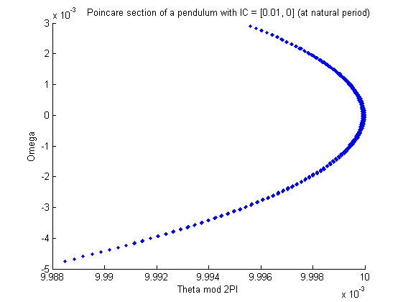Simplistic temporal Poincare section program
   1. PS4 2b trajectory at natural period.

This sectioned trajectory makes sense as it is of a pendulum that is swinging through the origin, thus that’s where it is the densest and becomes sparser along the edges of the arc where it spends less time. This pendulum has a periodic solution such that the natural period produces a nice repetitive section of the flow.

* 1. 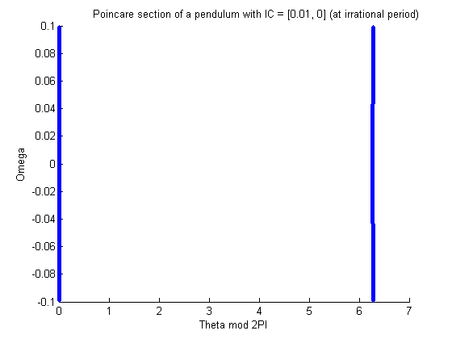Same pendulum plotted at an irrational multiple of T (the natural period)

This plot with T = T_natural * 2^(1/3) demonstrates how changing the sampling period of the section to one that is not rationally related causes the “sections” to be unrelated as all points along the trajectory are now being captured. This makes sense as rather than taking samples from only the beginning (or end) of each period, the cycles here are not properly defined so it instead captures points at any section of the trajectory making the overall plot much more zoomed out.

* 1. 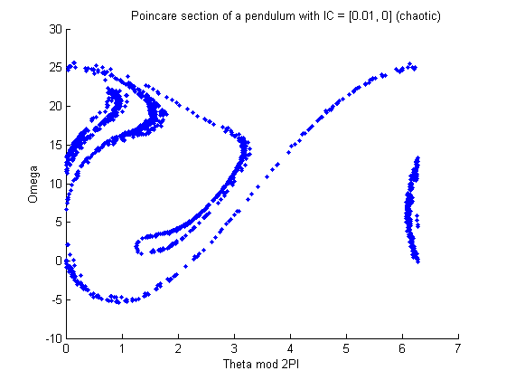Chaotic pendulum trajectory section using drive frequency =( 2.55*natural_freq) and A = .92
  2. As I increase the timestep while leaving the rest of the parameters from part c the same, the points begin to spread out and lose their form. By timestep h = .2 the plot still maintains its trajectory just sparser and allows for more points to be plotted off from the main paths as the step size grows too much to not fall off from the main course. As h grows larger than this the entire system is lost as the points fall too far off their true trajectory.

1. Interpolating Poincare section
   1. 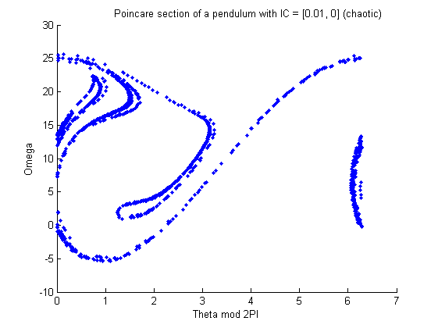Replot of 1c with improved Poincare section.

It is clear to see that this method that utilizes linear interpolation captures the points on the section more accurately than the original method. On this trajectory it is most noticeable along the left hand side where the flow tightens up creating more distinct curves rather than blobs. This is no surprise as you are getting a better approximation with the points that fall in between the two state vectors that cross a section as the mid-points tend to land closer to the section than either of the points that come right before or right after.

Running this chaotic pendulum with the same increased timestep of h = .2 shows a more define plot than the original, with tighter and more grouped points. This is expected for an improved method. There even still exists a loop of points in close proximity, whereas this feature is lost to a blob at the same step size for the original method.